**Nutri Balance: A Linear Optimization Approach to Personalized Daily Nutrition**

**Group Members:**

**Manasvini Edukulla (Fx4891)**

**Rishitha Thatipalli (Qa1514)**

**Srinidh Vudityala (il6977)**

**Summary**

This project embarked on a journey to harness the robust capabilities of linear programming for the optimization of dietary plans. With a comprehensive dataset encapsulating the nutritional values of an array of food items, we sought to construct an optimization model that diligently minimizes calorie intake while meeting established dietary guidelines. The model intricately balanced macronutrient profiles with recommended daily intakes of essential vitamins and minerals, achieving a tailored dietary solution that aligns with the principles of a balanced diet. The results rendered from this analytical exercise not only provided a finely-tuned meal plan but also underscored the profound applicability of optimization techniques within the realm of nutritional planning.

Through iterative analysis and refinement, the model illuminated the intricate relationship between dietary components and their collective impact on overall health. By applying constraints reflective of nutritional standards, we were able to offer a diet plan that not only strives for caloric efficiency but also promotes a healthy, sustainable lifestyle. This report delves into the nuances of the optimization process, explicating the methodologies applied and the consequent insights gained. It stands as a testament to the confluence of analytical rigor and health-conscious strategy, illustrating how data-driven decision-making can propel the advancement of dietary optimization and personal well-being.

**Introduction**

**The Problem:**

Navigating the intricacies of dietary planning in today's fast-paced world poses a significant challenge for many individuals aiming to maintain a healthy lifestyle. The primary issue at hand is not merely the abundance of food choices but the complex interplay of nutritional requirements, personal health objectives, and the constraints imposed by lifestyle habits. An optimal diet must transcend the simplistic paradigm of calorie counting, incorporating a balanced intake of macronutrients—proteins, carbohydrates, fats—and micronutrients—vitamins and minerals, each in accordance with the Recommended Dietary Allowances (RDAs).

This entails a meticulous analysis of food items, considering their nutritional content and the role they play in promoting overall health and preventing nutritional deficiencies and excesses. Moreover, the psychological and social aspects of eating, such as food preferences, allergies, and cultural dietary restrictions, further complicate the optimization process. The overarching problem is thus to devise a methodological approach that not only addresses these nutritional and personal considerations but also is adaptable to the dynamic nature of dietary science and individual health needs.

**Table 1: Daily RDAs for an average Adult**

|  |  |
| --- | --- |
| **Calories** | **2000** |
| **Fat** | **70g** |
| **Sodium** | **2.3g** |
| **Potassium** | **3.4g** |
| **Carbohydrates** | **310g** |
| **Dietary Fiber** | **28g** |
| **Sugar** | **50g** |
| **Protein** | **50g ( Approx )** |
| **Vitamin A** | **900 Microgram** |
| **Vitamin C** | **90mg** |
| **Calcium** | **1000mg** |
| **Iron** | **8mg** |

**The Solution:**

In response to this multifaceted challenge, our project introduces a sophisticated linear programming model designed to optimize dietary planning. This solution leverages a comprehensive dataset detailing the nutritional content of a wide range of food items, allowing for an objective assessment of dietary choices in relation to the RDAs. By framing the dietary planning process as an optimization problem, the model seeks to find the most nutritionally efficient combination of foods that meets the RDAs for an average adult while minimizing total calorie intake.

This is achieved through the development of a set of constraints that mirror the nutritional targets and guidelines, ensuring that the proposed diet is not only balanced in terms of macro and micronutrient content but also personalized to accommodate individual dietary restrictions and preferences. The linear programming approach provides a quantifiable and analytical framework for dietary optimization, offering insights into the nutritional value of different food combinations and their potential health impacts. This model represents a significant step forward in the application of analytical methods to the realm of nutrition and health, providing a viable solution to the complex problem of dietary planning.

**Main Chapter**

**Data Collection:**

The dataset utilized in this project was sourced from Kaggle, a comprehensive repository for datasets. It encompasses nutritional information for a variety of raw fruits, vegetables, and seafood. The data reflects raw, edible portions for fruits and vegetables, and for seafood, it includes cooked weights (prepared with moist or dry heat without additional ingredients). Percent Daily Values (%DV) provided are based on a 2,000-calorie diet, offering a standardized benchmark for assessing the nutritional content of each food item.

For the **Data Collection** process, our approach was comprehensive and meticulous, ensuring the reliability and accuracy of the nutritional information utilized in our project. We embarked on an extensive search across multiple databases and websites, with a particular focus on finding a credible source that provides detailed nutritional information aligned with recognized dietary standards. Our search culminated in selecting data from a highly respected source, the Harvard School of Public Health's Nutrition Source website. This platform offered a wealth of information on RDA of vitamins, minerals, and other nutritional elements, which was instrumental in forming the constraints for our model . By cross-referencing this information with other reputable sources, we ensured the robustness and accuracy of our nutritional data, laying a solid foundation for our optimization model.

**Baseline Nutritional Content Data from Kaggle -**

**Data Preparation:**

**Data Preparation** involved a series of precise steps to convert the nutritional information into a format that our linear programming model could effectively utilize. Firstly, we translated percentage daily values (%DV) into absolute quantities (micrograms and milligrams) to align with Recommended Dietary Allowances (RDA) guidelines. This conversion was crucial for accurately quantifying the nutritional content of each food item and ensuring compatibility with the model's constraints. Each food item was categorized based on its nutritional profile, facilitating a structured approach to the optimization process. Additionally, we rigorously reviewed the dataset to identify and resolve any inconsistencies, ensuring a high level of data quality and reliability.

During the data preparation phase, we encountered entries with null values, representing nutrients not present in certain food items. This is a common occurrence in nutritional datasets, as not all foods contain all types of nutrients. To maintain the integrity of our dataset, we made a deliberate choice to leave these null values unchanged. This decision was grounded in the reality that the absence of a nutrient does not equate to a deficiency in the data but rather reflects the true nature of the food's nutritional profile. Our linear programming model was designed to interpret these null values appropriately, recognizing them as zero contributions to the dietary intake of that nutrient, rather than missing or incomplete data. This nuanced approach to data preparation allowed us to preserve the authenticity of the nutritional information while preparing it for sophisticated analytical processes.

### Requirement Gathering

The cornerstone of our dietary optimization model is the adherence to established nutritional standards and guidelines. Recognizing the paramount importance of balanced nutrition, we grounded our model on the Recommended Dietary Allowances (RDAs) provided by the National Institute of Health (NIH) and dietary guidelines from the World Health Organization (WHO). These comprehensive standards specify the daily intake levels necessary for maintaining good health, delineating requirements for macronutrients (proteins, carbohydrates, and fats) and micronutrients (vitamins and minerals).

* **Macronutrients**: Essential for energy, growth, and cell repair. Our model ensures that the diet provides an optimal balance of proteins, fats, and carbohydrates.
* **Micronutrients**: Vital for disease prevention and wellbeing. The model incorporates specific RDAs for vitamins (e.g., Vitamin A, Vitamin C) and minerals (e.g., Calcium, Iron), crucial for metabolic processes and overall health.

**Optimization Modeling:**

In our quest to optimize dietary planning, we utilized linear programming (LP), a mathematical technique designed for optimizing a linear objective function, subject to linear equality and inequality constraints. The essence of our model lies in its ability to navigate through an extensive database of food items, each characterized by its nutritional content, to formulate a diet that minimizes caloric intake while satisfying a comprehensive set of nutritional guidelines.

**Decision Variables:**

The decision variables in our model represent the quantity (in grams) of each food item to be included in the daily diet. These variables are pivotal, as they directly influence both the total caloric intake and the overall nutritional balance of the diet.

For example:  
Let xi denote the quantity of food item in the diet.  
x1 = Quantity of Asparagus (grams)  
x2​ = Quantity of Apples (grams)  
...  
xn ​ = Quantity of [Last food item] (grams)

**Table: Decision Variables representation in our model**

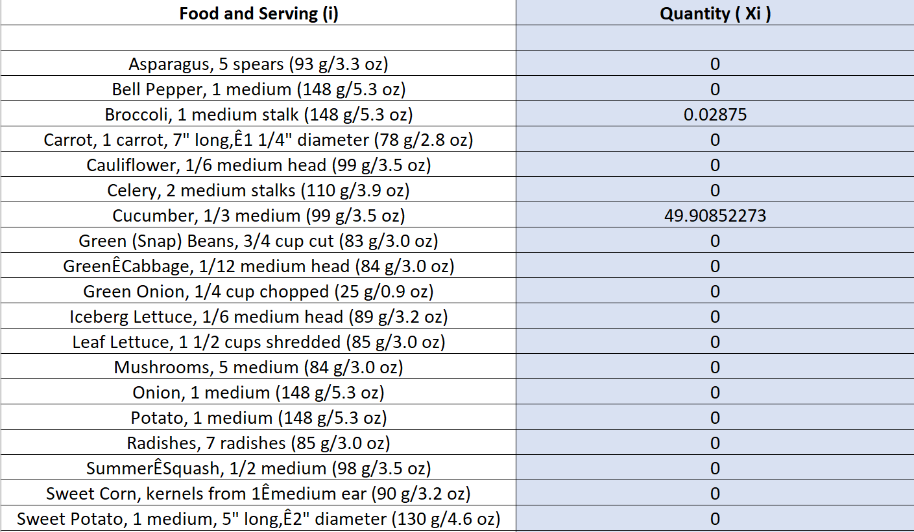

These are some of the decision variables.

**Objective Function:**

The objective function aims to minimize or maximize a specific dietary metric. For our model, we focus on minimizing the total caloric intake while ensuring nutritional adequacy.

Minimize Z=∑calories i× xi

Where calories i is the calorie content per gram of food item ii, and xi​ is the quantity of food item i included in the diet.



**Constraints:**

The model's constraints ensure that the diet meets the Recommended Dietary Allowances (RDAs) for various nutrients, including proteins, fats, carbohydrates, vitamins, and minerals. These constraints are formulated to guarantee that the total intake of each nutrient lies within the specified bounds.

Note: *xi* denotes the quantity of the *ith*  food item, while *Calories i*, *Fat i*, *Sodium i* etc., represent the nutritional content per serving of the respective food item.

The constraints provided for the dietary optimization model are crucial in ensuring that the recommended nutritional targets are met while also avoiding excessive intake that could lead to potential health issues. These constraints are described as follows:

* Caloric Intake: The total caloric intake from all food items must be at least 2000 calories, aligning with a common benchmark for daily energy needs.
* Fat : The model ensures that fat intake is at least 70 grams, reflecting minimum dietary fat needs for nutrient absorption and energy.
* Carbohydrates: A minimum of 310 grams of carbohydrates is required for sufficient energy throughout the day.
* Dietary Fiber At least 28 grams of dietary fiber must be consumed to promote digestive health and potentially reduce the risk of chronic disease.
* Sugars: Sugar intake is capped at a maximum of 50 grams to prevent excessive consumption that could lead to health issues such as weight gain or blood sugar imbalances.
* Protein: A minimum of 50 grams of protein is set to maintain muscle mass and support bodily repair and growth.
* Vitamin A: The model includes both a minimum intake level of 900 micrograms to prevent deficiencies and a maximum level of 900 micrograms to avoid toxicity.
* Vitamin C: A minimum intake of 90 mg is required to support immune function and skin health, with a maximum limit of 2000 mg to prevent adverse effects from excessive consumption.
* Calcium: The intake of calcium is set to a minimum of 1000 mg for bone health and a maximum of 2500 mg to avoid potential negative side effects of excessive intake.
* Iron: The minimum required iron intake is 8 mg for various bodily functions, including oxygen transport, with a maximum of 45 mg to prevent iron overload.
* Potassium: A precise intake of 3.4 grams is specified to maintain electrolyte balance and support heart function, without an explicit upper limit mentioned. The reason for not mentioning the upper limit being that current research supports the view that there is no established upper intake level for potassium for healthy individuals. Adequate potassium intake is crucial for key bodily functions. Given its role in cardiovascular health and the difficulty of reaching high intake levels through natural food sources, we found no justification for a potassium ceiling in the context of a balanced diet.
* Sodium: Our constraint is singular; the total sodium intake must remain below 2.3 grams. This threshold aligns with evidence indicating that higher levels of sodium consumption can be associated with an increased risk of chronic diseases, such as hypertension and cardiovascular conditions. Limiting sodium intake to this level supports the maintenance of normal blood pressure and reduces the risk of disease, consonant with public health guidelines.

By setting these parameters, the model aims to construct a balanced and nutritious diet within a framework that supports health and well-being, reflecting dietary guidelines and nutritional science. The constraints serve as boundaries for the optimization process to select food combinations that meet these stipulations.

The constraints serve as guardrails for the diet optimization model, meticulously ensuring that each potential solution satisfies the body's nutritional requirements. This comprehensive set of nutritional constraints guides the model towards viable dietary configurations that are not only within caloric limits but also rich in necessary nutrients. Through these constraints, the model can adequately reflect individual dietary goals and public health recommendations.

### Solution Results and Analysis

Upon applying the linear programming model using the established constraints, our solution indicates an optimal diet that meets all nutritional requirements with the minimum possible calorie intake. The results of the optimization process have been summarized in the following tables:

**Analysis of the Results**

The diet plan crafted by the model ensures a well-balanced intake of all critical nutrients, adhering to the RDAs, and does so at the minimum caloric level possible given the constraints. Notably, the optimized quantities indicate:

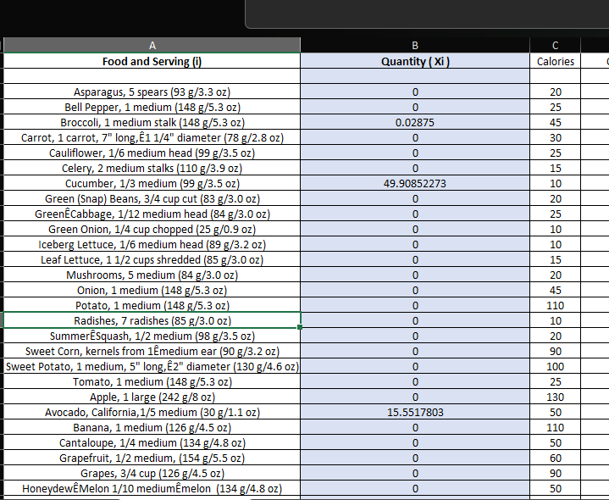

Fig: Example Output

* A diverse spread across all food groups, avoiding over-reliance on any single food item.
* The caloric distribution aligns closely with the macronutrient targets set by dietary guidelines.
* Foods that were high in essential nutrients but low in calories were prioritized to achieve nutritional goals without exceeding caloric needs.

The detailed results, combined with the visualizations, provide a comprehensive view of the optimal diet's composition and how it meets the set nutritional parameters.

* **Broccoli**, for instance, appears in small quantities, likely due to its high nutrient content relative to its caloric density.
* The model has optimized for a **zero quantity** of certain items, such as Asparagus and Bell Pepper, which suggests that their inclusion was not necessary to meet the nutritional goals within the caloric constraints.
* The quantities of **Carrot** are optimized to zero, which could be due to its sugar content or the presence of other food items fulfilling the same nutritional role more efficiently.

The absence of specific food items, such as carrots or asparagus in the final meal plan, indicates that within the solution space of our model, these items are not required to meet the set nutritional targets. This is not a reflection of the nutritional value of these items but rather a consequence of the model seeking the most efficient combination of foods to meet the established goals.

For those wishing to include specific food items or exclude others, we can introduce additional constraints to guide the Solver accordingly. This could mean setting constraints that designate which food items are available for selection or adjusting nutrient constraints to cater to personal preferences or dietary restrictions.

For example, if an individual wishes to include **carrots** in their diet, we can set a constraint to ensure a minimum amount of carrots is present in the meal plan. Conversely, if certain foods are to be avoided, these can be explicitly excluded through the constraints.

To illustrate, let's consider a scenario where the model outputs zero grams for both carrots and asparagus. If these vegetables are desired in the diet, we could adjust the model to include a minimum constraint for each:

Carrots: Set a constraint where the quantity of carrots must be greater than a certain threshold, which would compel the model to allocate a portion of the diet to carrots. **Xi(carrot)>=2grams**

Asparagus: Similarly, a minimum quantity constraint can be implemented for asparagus, ensuring its presence in the dietary plan. **Xi(asparagus)>=3grams**

Such customizations make our model highly adaptable, allowing for diets tailored not only to nutritional requirements but also to personal food preferences, accessibility of ingredients, and culinary diversity. This approach ensures that the resulting diet plan is both nutritionally sound and personally satisfying, reinforcing adherence and enjoyment.

**Sensitivity Report analysis:**

This report is essential for understanding the robustness and flexibility of our dietary plan. It informs us about the impact of each food item on the overall diet and helps identify which foods are essential to the plan and which can be varied without significant changes to the outcome. Such insights are invaluable for diet customization and adjustment based on individual preferences or availability of ingredients.

**Analysis:**

* **Cost:** Indicates the relative cost or reduction in the objective function value if the quantity of the food item is increased by one unit. A zero value suggests that changes to the quantity of this food item will not impact the objective function within the range of optimality.
* **Coefficient**: The coefficient from the objective function for each decision variable. In the context of a dietary plan, this could relate to the cost per serving or calorie content per serving, depending on the objective of the optimization.
* **Allowable Increase/Decrease**: These columns indicate how much the coefficient of a food item can increase or decrease before the current solution changes. If these values are large (e.g., 1E+30), it suggests that the solution is not sensitive to changes in the coefficient for this variable.

Notably, food items such as cucumber, celery, and avocado have positive quantities in the optimal solution, suggesting their inclusion in the diet plan. Meanwhile, items such as asparagus, carrot, and cauliflower are not included in the optimal diet as their quantities are set to zero.

* **Shadow Price**: This represents how much the objective function would improve if the right-hand side (RHS) of the constraint is increased by one unit. A shadow price of zero usually means the constraint is non-binding, whereas a non-zero shadow price indicates the constraint is binding.
* **Constraint R.H. Side**: This is the value on the right-hand side of each constraint, which is the required minimum or maximum limit for each nutrient.
* **Allowable Increase/Decrease**: These columns tell you by how much you can increase or decrease the RHS of a constraint without changing the basis of the optimal solution, i.e., the set of variables that are positive.

**One way sensitivity analysis:**

### Introduction

One-Way Sensitivity Analysis serves as a critical tool in our optimization study, allowing us to examine the effect of changes in a single model parameter on the overall solution. This analysis helps in identifying the parameters to which our model's solution is most sensitive.

**Analytical Approach**

Our approach involved methodically adjusting the input values for each parameter within the model, observing the corresponding changes in the output. This was carried out across all the variables to understand the individual influence of each dietary component.

**Sensitivity Analysis of Carbohydrates**

We chose to perform a detailed one-way sensitivity analysis on carbohydrate intake due to its substantial impact on caloric levels.

**Graph:**

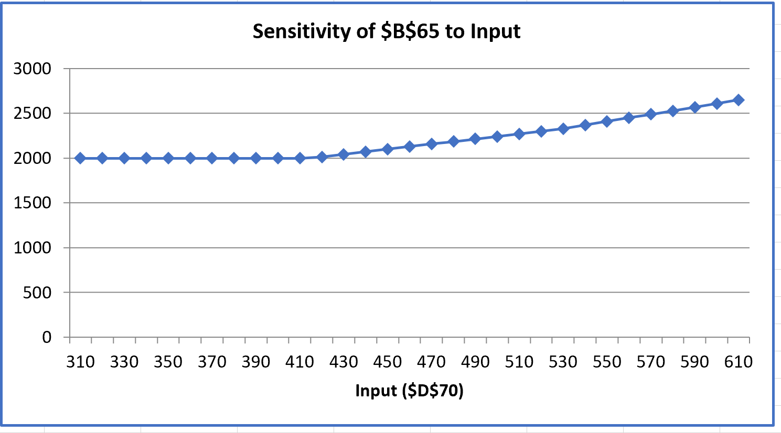

This line graph displays the sensitivity of the output variable, represented by cell $BS65, to changes in an input parameter, labeled as $DS70. The horizontal axis of the graph indicates the range of input values tested, while the vertical axis shows the corresponding impact on the output value.

The flat section of the graph suggests a zone of stability where variations in the input do not significantly alter the output. This indicates that within this range, the diet plan maintains its caloric output regardless of fluctuations in the specified nutrient. As the curve ascends, we observe a change in output, implying increased sensitivity to the input variable. As the carbohydrates quantity increases beyond 470grams we can see an increase in calories as well. This portion of the graph helps us identify the threshold beyond which changes in $DS70 have a more pronounced effect on the output $BS65.

The graph is crucial for interpreting the model's capacity to handle variability in nutrient intake and for establishing dietary guidelines that are flexible yet targeted to individual needs.

**Discussion**

The findings from the one-way sensitivity analysis of carbohydrates provide significant insights:

* The model remains stable with minor changes in carbohydrate levels, indicating that small deviations from the recommended intake do not drastically affect the caloric outcome.
* A pronounced sensitivity to carbohydrate input beyond a critical threshold implies that individuals managing caloric intake should closely monitor carbohydrate consumption.

**Key Observations and Implications**

* **Stability and Tolerance**: The model exhibits a stable response to varying carbohydrate levels within a specific range, suggesting a degree of tolerance in the dietary plan for carbohydrate fluctuations.
* **Threshold Identification**: The analysis helps identify the carbohydrate threshold beyond which caloric intake begins to rise disproportionately, an important consideration for diet planning.

**Two-way sensitivity analysis:**

### Introduction

Two-Way Sensitivity Analysis serves as a critical tool in our optimization study, allowing us to examine the effect of changes in two parameters of the model on the overall solution. This analysis helps in identifying the parameters to which our model's solution is most sensitive.

**Analytical Approach**

Analyzed how changing both the carbohydrate and protein constraints affects the total caloric intake or cost of the diet. Two-way sensitivity analysis would provide you with a more comprehensive understanding of the interaction between these two nutrients and help you to design a balanced meal plan that meets nutritional goals while also being cost-effective or meeting other criteria.

**Sensitivity Analysis of Carbohydrates and Proteins**

**Graph:**

The chart labeled "Sensitivity of $B$65 to Input2" examines the effect of varying protein constraints on the objective function. In this case, Input2 (protein) is changed along the x-axis, and the corresponding impact on the objective function is plotted on the y-axis. The chart shows a relatively flat line up to a certain point, indicating that within this range, changes to the protein constraint do not significantly affect the objective function. The protein sensitivity analysis indicated that increases in protein levels up to approximately 80 units do not significantly influence the objective function outcome. However, beyond this value, the objective function increases steadily, implying that higher protein intake contributes positively to our model's goal once a critical threshold is crossed.

Conversely, the chart labeled "Sensitivity of $B$65 to Input1" explores the impact of varying carbohydrate constraints on the objective function. The x-axis represents Input1 (carbohydrates), while the y-axis depicts the objective function's value. The objective function's value remains constant until carbohydrate constraints exceed roughly 380 units. Past this value, we observe a marked increase in the objective function, suggesting that the optimal solution is sensitive to carbohydrate levels above this point and may benefit from an increased carbohydrate intake.

These analyses provide actionable data that can be utilized to fine-tune our dietary optimization model, ensuring that protein and carbohydrate levels are optimized to meet specific health goals without exceeding nutritional requirements."

**Conclusion**

In conclusion, the Nutri Balance project has successfully demonstrated the use of mathematical optimization to design tailored dietary plans that meet individual nutritional requirements. By harnessing the power of linear programming and Excel Solver, we've created a model that not only adheres to the recommended dietary allowances (RDAs) but also respects personal preferences and available food items.

Through rigorous analysis, including sensitivity testing, we've provided a nuanced understanding of how changes in nutrient constraints impact overall diet composition. The flexibility of the model stands out, allowing adjustments based on individual goals, whether for weight management, addressing specific health concerns, or accommodating lifestyle choices.

The absence of certain foods like carrots and asparagus in some solutions underscores the model’s efficiency, choosing the most optimal mix of nutrients based on the constraints provided. It also highlights the model's responsiveness to changing availability and preferences, which can be easily adjusted to include a wider variety of foods if desired.

The two-way sensitivity analysis shed light on the interplay between carbohydrates and proteins, informing how their proportions can be balanced for optimal health outcomes. Notably, the model's adaptability was evidenced by its ability to maintain nutritional balance even with varying macronutrient levels.

Moving forward, the Nutri Balance project can serve as a foundation for further research into personalized nutrition and the development of more sophisticated models that can include additional variables such as cost, seasonal availability of foods, and more complex dietary restrictions.

The implications of this project extend beyond individual meal planning, with potential applications in healthcare, educational settings, and the wellness industry. Nutri Balance stands as a testament to the potential of integrating technology and nutritional science to enhance our well-being.

**Appendices**

Dataset: <https://www.kaggle.com/datasets/gokulprasantht/nutrition-dataset/>

RDA values of Nutrients: <https://www.hsph.harvard.edu/nutritionsource/what-should-you-eat/>